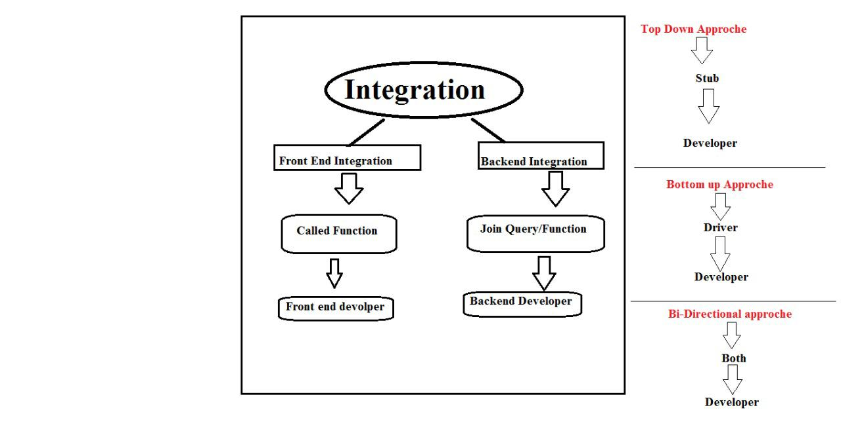

* + - * **Integration Testing :-**

It is Developer task

In this testing developer merge the old module into the new module.

Developers develop no. of modules separately and adding in one application it is called integration.

**\*\* There are two types of integration :-**

1. Front End Integration (FEI) -----

It is related to GUI (graphical user interface) or UI (User Interface)

Here Front end developer connects two modules using “Called” Function.

1. Back End Integration (BEI) -----

It is related to data bases.

Here developer connect two or more tables in data bases using “JOIN QUERY” .

Integration testing it is the process of checking correctness and completeness of the flow of functionality whenever integration of module completed.

**Whenever Integration of modules done then Integration testing start by Developer for that he use three approaches**

**\*\* Testing Approaches :-**

1. Top Down approach
2. Bottom approach
3. Bi-directional approach/Hybrid Approach
4. Top Down Approach :-

When Dev have main module but don’t have sub module (Next Module) in that condition developer use top down approach.

At that time developer create dummy module Called “STUB”.

STUB is created by XML (Extensible Markup Language) Programming Language.

STUB is checked by using SOAP UI tool.

1. Bottom Up Approach :-

When Dev have sub module but don’t have main module in that condition dev use Bottom up approach.

At that time developer create dummy module Called “Driver”.

Driver is created by XML (Extensible Markup Language) Programming Language.

1. Bi-directional approach/Hybrid Approach :-

It is combination of Top Down and Bottom Up Approach.

-For Example: If developer developed Login Page and he have to check functionality with Sign UP and Home page that condition developer create dummy module of Sign up Page by using Driver and dummy module of Home page by using Stub.